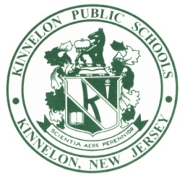
KIEL SCHOOL
115 KIEL AVENUE • KINNELON, NEW JERSEY 07405
TEL: (973) 838-0611 • FAX: (973) 838-6338
www.kinnelonpublicschools.org
Ivonne Ciresi, Principal

September 6, 2017

Dear Parents/Guardians,

Welcome to the new school year at Kiel School! I am thrilled to work with your child, you and the staff of Kiel School as our School Counselor. My goal is to support and develop students’ social and emotional learning skills as they work toward reaching their academic goals.

I have been working with students and families in Kinnelon since 1996 as an elementary classroom teacher in second grade and kindergarten. In May 2017, I received my school counseling certification after graduating with a Masters of Education in Professional Counseling with a concentration in School Counseling. Over the past seven years, I have also been involved in implementing and sustaining our district-wide Full Value character education model to support the students’ social and emotional needs as well as serving on the School Safety Team to monitor and improve school climate.

My focus will include helping students’ develop and enhance their social skills and coping skills, improve self-regulation, strengthen self-efficacy, and become resilient problem solvers. I will be meeting with classes, small groups and individuals to support our students in their school journey. Please contact me if you need any assistance, resources or have any questions about our school counseling program.

Sincerely,

Sarah Tinney
Kiel School Counselor

School Counseling Department
(973) 838-0611 x6075
tinneys@kinnelon.org

